Raising a Requisition
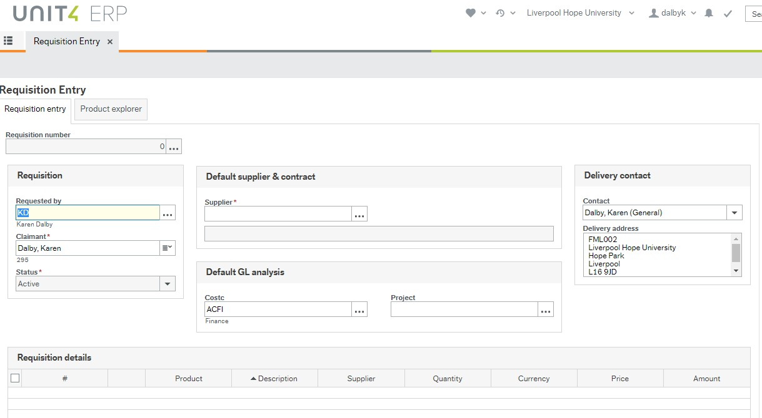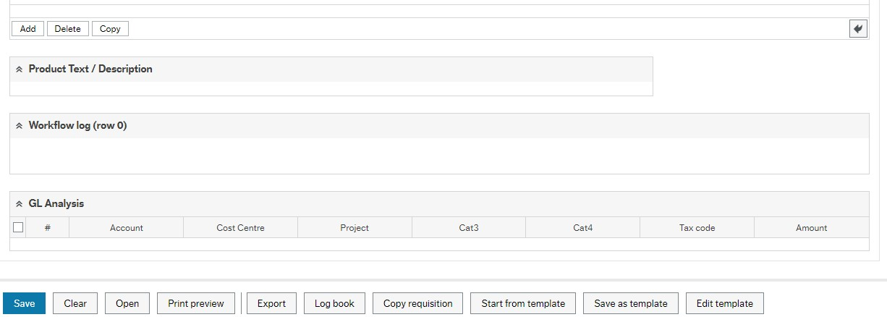
Procurement > Requisition
s > Requisition

Entry

- Start typing the supplier code or the supplier name, any suppliers matching the description will be displayed to select from.
- Entering a sundry supplier* will produce an extra box for the supplier’s name, address, town, county and postcode.
*For ALL Sundry customers and suppliers, the name, address, Town/city and Post Code must be entered.
- The Default GL analysis will display the users default cost centre. This value can be changed, as users can enter a requisition for any cost centre, and the requisition will be directed to the appropriate budget holder when saved.
- Enter a project code which is valid for the cost centre.
- An alternative delivery address can be selected (in the Delivery Contact section) if the user is set up with more than one address.
- Requisition details / lines
Click the first line to start entering details.
  - PRODUCT: A product (text) not an account code (numeric) must be entered. Start typing, and a list of matching product codes will be shown. To find a product click on the dropdown, to the right of the field, and select ‘Value Lookup’. Search using text, or a numeric account code.
  - DESCRIPTION: This prints on the requisition. You must overtype this ‘Description’ with a clear description of the product or service you wish to buy. This is the information given to the supplier about what is being ordered and forms a contract between the University and the supplier so it must be accurate.

This is also the information that approvers will use to approve the requisition so try to ensure that it makes sense.

  - QUANTITY: Enter the quantity of item you are ordering. o CURRENCY: Defaults to GBP but can be changed (depending on the supplier). o PRICE: Enter the cost of the item. o AMOUNT: Display only. Calculated as quantity x price.
- Product Text / Description
Additional text can be entered here, this will print on the purchase order. If using a ‘framework agreement’ enter the contract number.
- Workflow log
A message can be entered here, this will be available to the budget holder but will not print on the purchase order.
- GL Analysis
A GL Analysis line will be produced for every requisition line entered. The code is derived from the cost centre and project at the top of the screen, and the product on the individual line.
o Account, cost centre and/or project can be changed on any line, if required. o Asset is not used unless the nominal account relates to a building (mainly used by Estates) o Tax Code should be PS for standard rated items and PE for exempt/zero rated items.
- If the currency is NOT GBP the tax code should be PE.
- All orders will print net of VAT, whatever the tax code entered.
o Amount as per the line amount
- Add Further Rows to a Requisition o To order multiple items from the same supplier, either copy an existing row or add a new, blank row.
  - To copy a row, ensure one row is ticked and click on Copy. The Copied line can be amended as required.
  - To add a row, simply click on the next line, or on Add, and enter details as before.
- Delete a Line on a Requisition o Ensure the line(s) to be deleted are ticked and click on Delete.
How to Attach a Document:

Why do I need to do this?

In order to allow for seamless authorisation, documents need to be attached to a requisition where
necessary. This forms part of the audit trail and demonstrates that the appropriate process has been followed and value for money has been evidenced. If appropriate documents are not attached, the requisition may be rejected with a request for them to be attached.

You need to attach documents:

- For purchases above £25,000. In this case attach a tender report or a Single Supplier Justification (fully completed and signed).
To attach documents, click on the paperclip icon in the top right hand corner of the screen. Click on ‘Add a Document’ and ‘Upload’ to locate the file to be uploaded. Click on ‘Save’. Exit the documents screen by the ‘X’ in the top right hand corner.

- Click on Save when complete and ensure a Requisition number is generated.
- Copy a Requisition o Click on Open (at the bottom of the screen) and enter the requisition number for the requisition to be copied.
  - When the requisition is displayed, click on Copy Requisition (at the bottom of the screen). The copied requisition may be amended as required.
  - When Saved, a new requisition number will be generated.
- Templates
For similar regularly raised requisitions, a template option can be used to save a default template which can then be amended, as required, to generate a new requisition.
  - Create a Template
- Create a requisition as usual with the details which are to be the basis of the template.
- When the details have been entered click on ‘Save as Template’ and enter a Template name.
- A requisition number will be generated, but the requisition will not be sent for approval.
- Retrieve a Template
  - Click on Start from Template, this opens a value lookup screen.
  - Enter the search criteria (template name or requisition number) to retrieve the required template.
  - Click on the details to display the template in the Requisition Entry screen.
  - The template can be amended as required.
  - When Saved, the requisition will be sent to the budget holder for approval, and the original template will be retained.

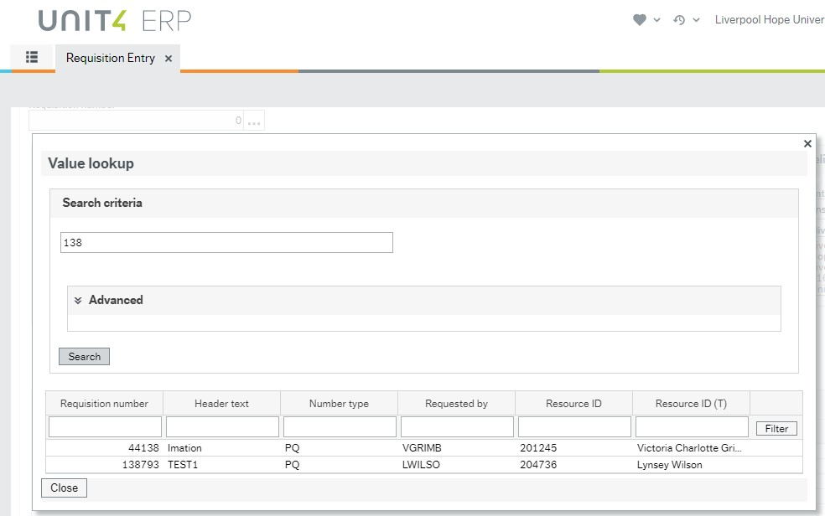
Enter the template name
or
requisition number to
find the template

Click on the template to retrieve it.

- Change a Template
  - A template may be changed so that future requisitions are generated from the updated template. Click on ‘Edit Template’ and amend as necessary. When ‘Saved’ the amended details will replace the original template.

